A
Celebration
Of the
Life
of
Ruth Carin Hatcher Heumier
11/14/29 to 10/29/2014

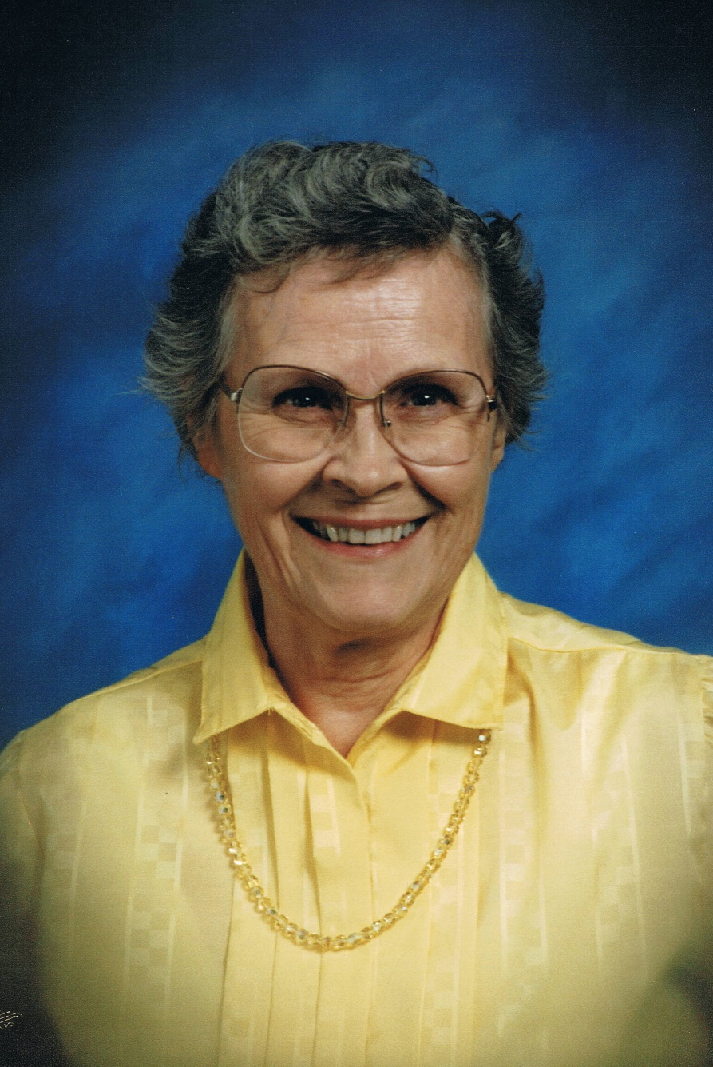

Prayer and greeting
Pastor Paul Pierce

Congregational Hymn
#8 Praise to the Lord, the Almighty, the King of Creation (v. 1 only)

Scripture reading, Revelation 4:1, Poem “The Other Side”
Son, Corey Heumier

Trio: “Until Then”
Grand-daughter, Cherry Aasen, grand-daughter-in-love Brooke Aasen, singing;
grand-daughter, Alyssa Hoover, signing
(this was Mama’s favorite “going Home” hymn all her life!)

Scripture reading, I Co. 15: 20-22, 45, 47-49, 53-57
sons, Gary and Tim Heumier

Ruth’s life in pictures
narrative, daughter, Susie Aasen

Time of sharing
brother, David Hatcher, opening

A Word to Family and Friends
Pastor Paul Pierce

Congregational Hymn
#549 Face to Face

2 Thess. 4:13-18, closing prayer
Pastor Paul Pierce

Reception following immediately after service.
Please join us and share your memories of Mama.

Our mother’s life is a shining witness to the fact that although our history may explain us, by God’s grace it does not have to define us. Without knowing something of Ruth’s childhood, it is impossible to understand just how amazing it is that she was able to have the loving marriage, foster the close, caring family, and create the welcoming home that she did.
Ruth was born in Liberty, Missouri on November 14, 1929. Her sister, Lillian, was born a year later, and her brother, David, a year after that. Their parents’ marriage was troubled. For reasons the children did not understand, their father was absent from the home much of the time throughout Ruth’s entire school career. Even so, Ruth still adored him. Her mother found herself betrayed and left to support and raise three children essentially on her own. With no modeling and no support system, the burden she carried radically affected her ability to be an attentive or loving mother. Ruth felt very keenly that lack of love and approval. The parents finally divorced when Ruth was 16. (In later years, relationships were much different, and both her parents ended up being influences for good in the lives of their grandchildren.)
All while the children were growing up, the family moved frequently, living in a series of towns in Missouri and Wyoming – so much so that the siblings never attended the same school two years in a row until Ruth reached high school.
Because their mother had to work, Ruth and Lillian had the responsibility of running the household from very young ages. The frequent moves and the lack of free time resulted in an extremely close bond forming between the girls; they were each other’s only friend, companion and confidante. When Lillian died at the age of fifteen from a form of blood cancer, it was a devastating loss. Only in her last years of high school did Ruth make another real friend, and the two remained close until Ruth’s death.
While a college freshman studying interior design, Ruth met fellow student “Chuck” Heumier, a WWII pilot at college on the GI bill. The two were married on January 1, 1950. In his family, she gained her first experience in what a close, supportive family was like. Chuck worked as a game warden for the State of Wyoming for the next eight years, moving to various stations, during which time Timothy, Gary, Sandra, and Corey were born. In 1958, Chuck became a federal game agent and the family headed off to McGrath, AK. After only eleven months there, Alaska gained statehood and the family was transferred to Roswell, New Mexico, where their youngest child, Susan, was born, then to San Angelo, Texas, where they remained for the next eleven years – the longest time Ruth had lived in one place in her entire life. In 1972, Chuck was transferred to Brigham City, Utah. When he retired in 1978, the couple moved to Chuck’s hometown in Wyoming, to care for his mother. After her death in 1989, Chuck and Ruth moved to Otis Orchards, WA, close to daughter Sandy and family. Ruth was widowed in 1991 when Chuck died of a heart attack, but stayed in the house they had bought . In 2006, Sandy and her family moved across the state not far from Seattle, WA. In 2008, Ruth followed them across the state, moving to Lacey, WA, close to daughter Susie, but still only an hour south of Sandy.
Ruth and Lillian came to know the Lord during VBS when Ruth was 10 and Lillian 9. Although that faith was slow to begin maturing until after her marriage, for the rest of Ruth’s life that faith would form an integral part of everything she did. No matter where the family lived, one of the first things Ruth did was to find a church and become an active member. However, her most memorable ministry lay in her everyday life. She honored her husband. Although she didn’t entirely escape copying the example of mothering she had had of being critical of and sharp with her children, she worked hard to encourage them, praise them, to have fun with them, and to do things to make them feel valued. Because she so wished she had had someone to mentor her as a young mother, she became a mentor to all young mothers around her. Because of the loneliness she experienced growing up, she had a heart for the sick and lonely. Because of her early loss, she felt keenly the bereavement of others. Because of the austerity and isolation of her childhood, she placed a high value on hospitality. She prayed faithfully for family, friends, and others she encountered in the course of her daily routines. She loved music, especially the old Baptist hymns, and was often heard singing them around the house.
The acrimony between her parents, the absences of her father, and the lack of any warmth or tenderness or sense of being valued by her mother led Ruth to set one goal in life: to create a home where the husband and children knew they were loved, a family where all members cared for and supported each other. All too aware of how very far short she fell of being the mother she wanted to be, she never failed to credit God’s grace for just how much that goal was achieved, not only in her own family, but as she saw it blossom in the lives of her children’s children. Her example of faith will bear fruit for many generations to come.
Ruth is survived by her brother; her five children; fourteen grandchildren; one great-grandson, and six great-granddaughters; plus three grown grandchildren and three great-grandchildren added to the family through her oldest son’s second marriage 10 years ago, all of whom she welcomed as her own.
In one of Ruth’s favorite hymns, “Great is Thy Faithfulness”, is a phrase that she felt summed up her life: “Blessings all mine, with ten thousand beside!”
AMEN!

